**Assignment 5 A**

**By Neville Dabre**

**Snapdeal.com – Cookie Information**

**Cookie name – eid**

**Content –** [**nevil_dabre@yahoo.com**](mailto:nevil_dabre@yahoo.com)

**Domain - .snapdeal.com**

**Path – /**

**Send For – Any type of connection**

**Expires – Monday, July 17, 2084 8:23:05 pm**

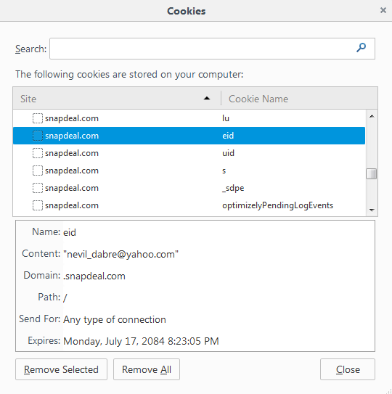

Image : Firefox Cookies

**Question 1 🡪 How I selected web site for cookie shown above!**

🡪As per the instructions given in the file, I removed all the cookies.

I researched about many popular sites like Facebook.com, Gmail.com, Flipkart.com and Yahoomail.com but above sites are not storing usernames directly into cookies.

Many sites encrypted with string or a number so it was difficult to track which cookie was storing my user id.

So researched more about why I was unable to see my user Id into cookies and came across following information.

<https://www.google.com/policies/technologies/types/>

*Google use cookies called “SID” and “HSID” which holds encrypted records of user’s Google account ID.*

So I tried at **Snapdeal.com**, it is an Indian ecommerce sites which sells many types of products through their website. There are more than 10 cookies were created after I logged in. So I Searched and Found it with Cookie name **“eid”** which was having my username.

So Snapdeal.com will remember my name and my items I searched on their web site and next visited them they showed me items related to my interests and other features.

**Question 2.a 🡪 Sites affected after disabling cookies**

**1. Yahoomail.com –** Refused to allow login and displayed message like

The browser you're using refuses to sign in. (cookies rejected)

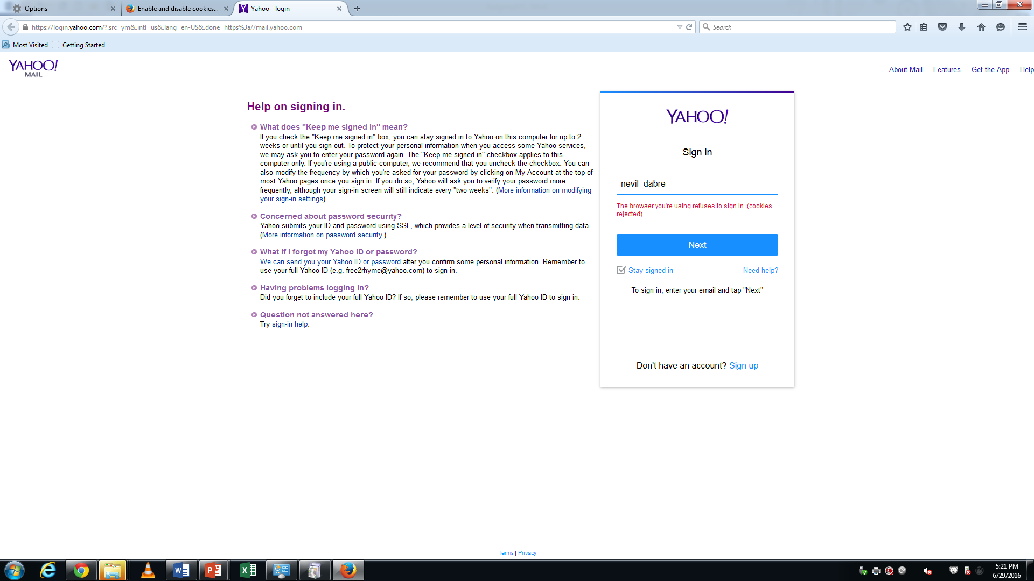

**Image: Mail.Yahoo.com**

**2. Facebook.com -** A popular social networking website also denied access with disabling cookies above browser.

Error message was displayed – Cookies Required

Cookies are not enabled on your browser. Please enable cookies in your browser preferences to continue.

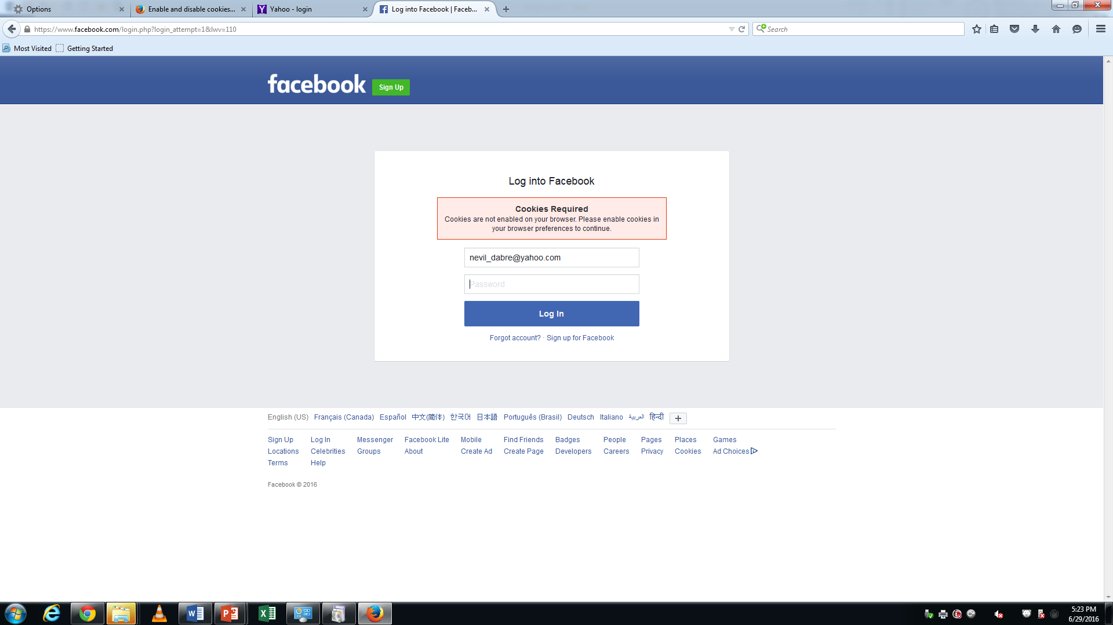

**Image : Facebook.com**

**3. Gmail.com –** Whereas **Gmail.com** redirected me to another webpage which was showing information about cookies.

### How enabling cookies helps you

Turning cookies on makes it easier for you to browse the web. Cookies are files created by websites you’ve visited, which store information, like the language you prefer or profile information.

At Google, we use cookies to improve the quality of our service. Check our [Privacy Policy](http://www.google.com/privacy.html) for more information about cookies.

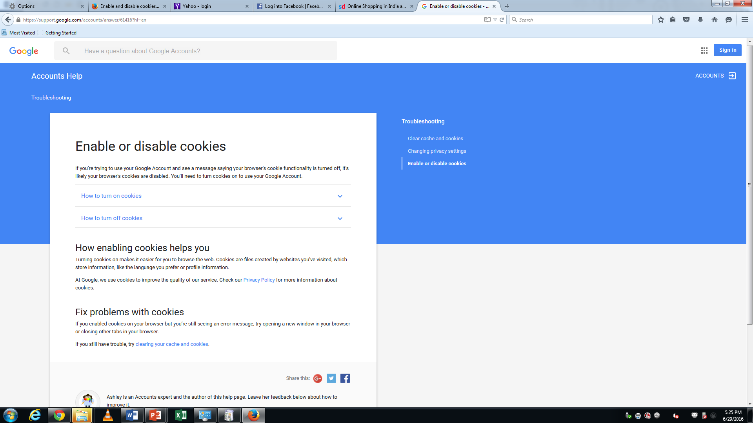

**Image : support.google.com**

**4. Snapdeal.com –** This site was *stopped responding* login buttons. I was unable to click on the login button. So I was unable to do any purchase or unable to add any product in my shopping cart. So disabling cookies affected all major sites as well as their functionality.

**Question 2.b 🡪 Cookies Advantages:**

1. **Convenience:** Cookies remember information like user-id, address, phone numbers etc. So basically it saves time of user and speed up the process. There are many sites for example insurance companies, E-commerce sites, Banking sites etc. ask for many information every time we try to register for any service or fill address for delivery. So cookies simply stores user’s general information and provides easy access.
2. **Personalization:** Initially when we register or Login to a new website it stores our name as well our preferences so in future they can server us better. So sites like Bestbuy.ca, Amazon.ca provides suggestion based on our last search. Sites like youtube.com, Facebook.com provides content related to our visits or likes.
3. **Effective Advertising:** Sites like Google.com, Facebook.com use cookies to deliver appropriate Advertises to their customer. Advertising will be based on Region, Language, Likes, and Interests etc.
4. **Ease of Access:** Cookies don’t just remember about user’s likes and interests additionally it remembers about fonts size. Also occupies less size on user’s memory.

**Question 3.a 🡪 How Cookies Can Harmful:**

Cookies are designed to help users as well as websites to serve better. But there are some websites or companies uses cookies to track user information.

**Less Secure**

Cookies are not secured because they are stored in normal text file. Any other user or website can read the content of the cookies file. So basically sites which uses less encryption can expose your data to phishing sites and they can get vital information.

**Tracking cookies or Third-party Cooking**

When we visit websites which shows ad, sites create cookies known as Tracking cookies or Third Party Cookies. They illegally or without knowledge gather user’s personal data, behavior, purchase history or online transactions. Websites later sells information to other vendors, groups and individuals.

**Cookies Theft**

As many hackers can use cookies steal personal information. Cookies are plaint text files so hacker can read file and use it in inappropriate manner. Important information like login id and password saved in cookies can give access to secure sites or important bank sites.

**Question 3.b 🡪** Cookies Disadvantages or Limitations:

There are limitations with using Cookies as follows:

1. A single site can store just 20 cookies and 4kb data per cookie.
2. Cookies will not work if user sets his browser security set very high.
3. If user disable accepting cookies, then websites functionality affected.
4. Cookies stored in text files so it’s less secure.